Safe Crib with Auto Hazard-Detection

ECE 445 Final Report

Team 13

Feng Zhao (fengz3)

Xinlong Dai (xinlong3)

Yuhao Yuan (yuhaoy3)

TA: Dushyant Singh Udawat

Spring 2023

**Abstract**

Nowadays, parents find it hard to take care of their baby and ensure their baby’s safety when the baby is in a crib. Our project team created a safe crib solution to help the parents. First, our safe crib can report to the parents about whether the baby is trying to climb out of the crib. Second, the crib can detect the baby’s crying sound and notify the parents, which might indicate that the baby needs care. Third, the crib can notify the parent about whether the baby is moving inside the crib, and the parents can decide whether they need to move their baby out of the crib for activities. Given appropriate packaging, our project has the potential for commercialization.

**Contents**

1. Introduction 1

1.1 Purpose 1

1.2 Functionality 1

2. Design 2

2.1 Subsystem Overview 2

2.2 Crib System 2

2.2.1 Crib Sensor Subsystem 2

2.2.2 Crib Control Subsystem 4

2.2.3 Crib Power Subsystem 6

2.3 Monitor System 6

2.3.1 UI Subsystem 6

2.3.2 Monitor Control Subsystem 7

2.3.3 Monitor Power Subsystem 8

3. Cost & Schedule 9

3.1 Cost 9

3.1.1 Labor 9

3.1.1 Parts 9

3.1.3 Sum of Costs 9

3.2 Schedule 10

4. Requirements & Verification 12

4.1 Crib System 12

4.1.1 Crib Sensor Subsystem 12

4.1.2 Crib Control Subsystem 12

4.1.3 Crib Power Subsystem 14

4.2 Monitor System 15

4.2.1 UI Subsystem 15

4.2.2 Monitor Control Subsystem 16

4.2.3 Monitor Power Subsystem 16

5. Conclusion 18

5.1 Accomplishments 18

5.2 Uncertainties 18

5.3 Future Work / Alternatives 18

5.4 Ethical Considerations 18

References 20

Appendix A Requirement and Verification Table 21

# 1. Introduction

## 1.1 Purpose

Securing an infant's safety within a crib can be challenging, particularly when dealing with active babies. It's known that babies as young as eight months can begin climbing out of their cribs [1]. Continuously monitoring a baby at home is impractical since parents can only sometimes be in the baby's room. Additionally, a baby's cry can signal various needs, such as hunger, a diaper change, illness, or burping. Ignoring these cues can lead to malnutrition, skin irritation, or even bladder infections, highlighting the importance of attending to a crying baby [2].

To resolve this issue, our team proposes an innovative crib equipped with hazard detection. This electronic solution is an innovation to the market as it identifies potential dangers and notifies the parents. The crib employs multiple types of sensors to monitor the baby's state and alerts parents when necessary. Firstly, ultrasonic sensors atop the guardrail detect if the baby is attempting to climb and potentially fall. Secondly, a sound sensor on the guardrail picks up the baby's cry, indicating a need for food or a diaper change. Lastly, pressure sensors arranged in a matrix below the mattress detect the baby's movement within the crib, helping parents decide whether to take care of the baby. The crib system's microcontroller processes the sensor data and communicates any safety concerns to the parents' monitoring system.

## 1.2 Functionality

The project has three high-level functionalities listed below.

1. The safe crib system needs to alert the parents about whether any of the baby’s body parts has reached a height of 20 in from the bottom of the crib. This functionality ensures that parents can be alerted if the baby is trying to climb the guardrail and prevent the baby from falling from the crib and getting hurt.

2. The safe crib system needs to alert the parents about whether the baby’s crying is higher than 86 dB for 2 s when measured at 34 in away. This functionality lets parents be alerted if the baby is crying and come to take care of the baby.

3. When the monitor system is within 10 m of the crib and at most three 11.4 cm or thicker walls from the crib, the crib system needs to be able to send updates to the monitor system at the parent’s side within 3 s of the occurrence of the safety event. This is because the room spacing inside an apartment is 10 m long with walls in between. This functionality notifies parents of the baby’s state and receives alarms on time so that they have enough time to take action to protect the baby.

# 2. Design

## 2.1 Subsystem Overview

As shown in Figure 2.1, the safe crib system consists of six interconnected subsystems. The crib and monitor power subsystems supply a consistent 5 V DC voltage to components within the other subsystems. The sensor subsystem is responsible for gathering data about the baby's current condition and transmitting it to the microcontroller unit (MCU) within the crib control subsystem. The MCU processes this information to determine the baby's status and sends an activation signal to the monitor system via Bluetooth. The monitor control subsystem identifies the baby's current state based on receiving and decoding the activation signal. It directs the user interface (UI) subsystem to display relevant messages about the baby's situation and trigger a buzzer alarm if necessary. Figure 1 and 3 in Appendix A show the schematics for the crib system and the monitor system, and Figure 2 and 4 show their PCB layouts.

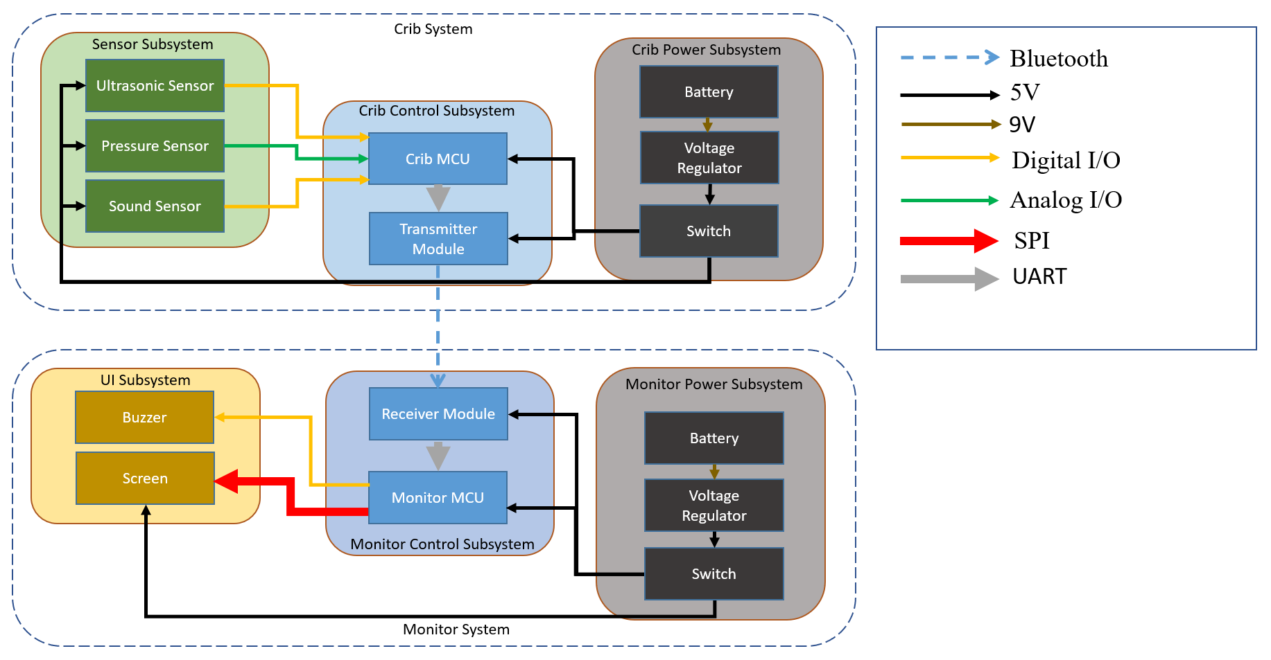

Figure 2.1: System Block Diagram

## 2.2 Crib System

### 2.2.1 Crib Sensor Subsystem

The crib sensor subsystem is responsible for collecting the measurements regarding the baby’s current state. Three types of sensors are incorporated inside this subsystem. They are ultrasonic sensors, sound sensors, and pressure sensors.

Four ultrasonic sensors are positioned along one side of the crib edge, forming an ultrasonic sensors array. They connect to the microcontroller via digital I/Os. They constantly measure the distance from one side of the crib to another. When the baby stands up and breaks the measurement, we can tell that the baby has reached the height limit. In principle, the sensor sends an ultrasound, which will soon be echoed back if it hits some objects. The programmable MCU in the control subsystem records the time it takes for the ultrasound to propagate and reflect back to the sensor and calculates the distance based on the recorded time multiplied by the sound speed [3]. The calculation is based on equation (2.1).

$distance = speed × time = \frac{34 cm}{ms}×duration(ms)$ (2.1)

One sound sensor is responsible for detecting the surrounding noise intensity and returns a digital “high” voltage, which is considered as an alarm that the baby is crying, to the microcontroller if a sound above our particular interested intensity level threshold is detected, otherwise it returns a digital “low” voltage. Based on our investigation and experiment, we observed that a 100 dB sound [4], the intensity same as the baby’s crying sound, is attenuated to 86 dB near the microphone of the sound sensor. Therefore, we determine the desired threshold to be 86 dB. In the later section, we will verify the sensor can send alarms when the sound intensity level is beyond that threshold.

The pressure sensors are the most sophisticated module to be designed because we encountered a design issue because the microcontroller has its pin shortage since there are five analog pins inside the microcontroller, whereas 15 pressure sensors need for data collection. However, we designed a five-by-three pressure sensor matrix to resolve this issue, as shown in Figure 2.2.

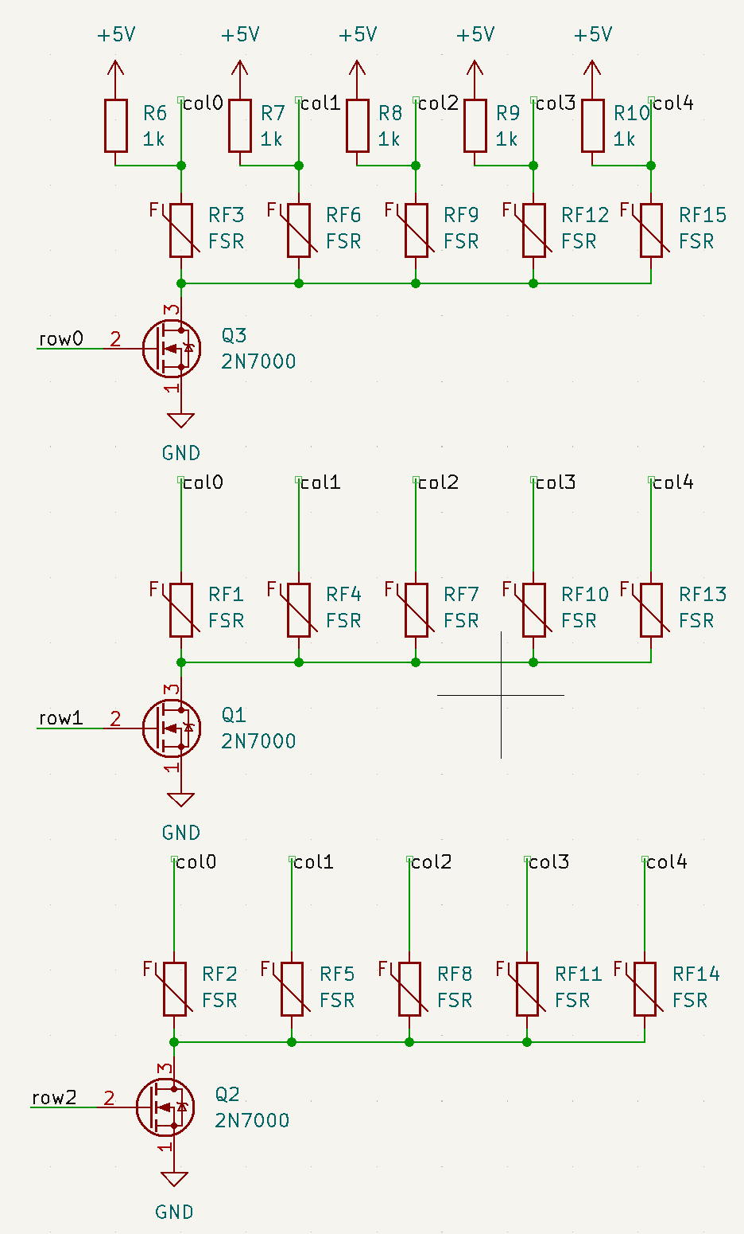

Figure .2: Pressure Sensor Matrix Schematic

Since we plan to use 15 pressure sensors, we divide them into three columns such that every five of them forms a pressure sensor row, controlled by an n-channel MOSFET, and its gate is connected to one digital pin of the microcontroller. If the microcontroller sends a 5 V voltage pulse, the MOSFET will generate drain-to-source current and pull its resistance down, thus serving as a switch. We generally use three MOSFETs, each controlling the current flow through a pressure sensor row. Based on this approach, the measurements from all pressure sensors can be recorded without switching to a more advanced microcontroller (ATMega2560, for instance).

### 2.2.2 Crib Control Subsystem

The crib control subsystem is designed to receive and analyze the data from the crib sensor subsystem, generate the corresponding message, and send them to the monitor control subsystem via Bluetooth. Based on this consideration, we connect the Bluetooth module to the microcontroller through the defined serial TX/RX ports and the UART protocol, so it can successfully receive the information from the microcontroller and send them out. In Figure 2.3, the schematic of the crib control visualizes that. Table 2.1 describes our microcontroller pin usage.

Apart from the Bluetooth module, we add an ISP connector to the microcontroller to make it programmable. We also connect an external 16 MHz crystal oscillator with two 22 pF capacitors to the microcontroller to serve as the clock generation [5].

|  |  |  |  |  |  |  |  |  |
| --- | --- | --- | --- | --- | --- | --- | --- | --- |
| Components | ultrasonic sensors | | pressure sensor matrix | | sound detector | | Bluetooth module | |
| MCU pin type | analog | digital | analog | digital | analog | digital | analog | digital |
| MCU pin usage | 0 | 8 | 5 | 3 | 1 | 0 | 0 | 2 |

Table 2.1: MCU pin usage on different types of sensors

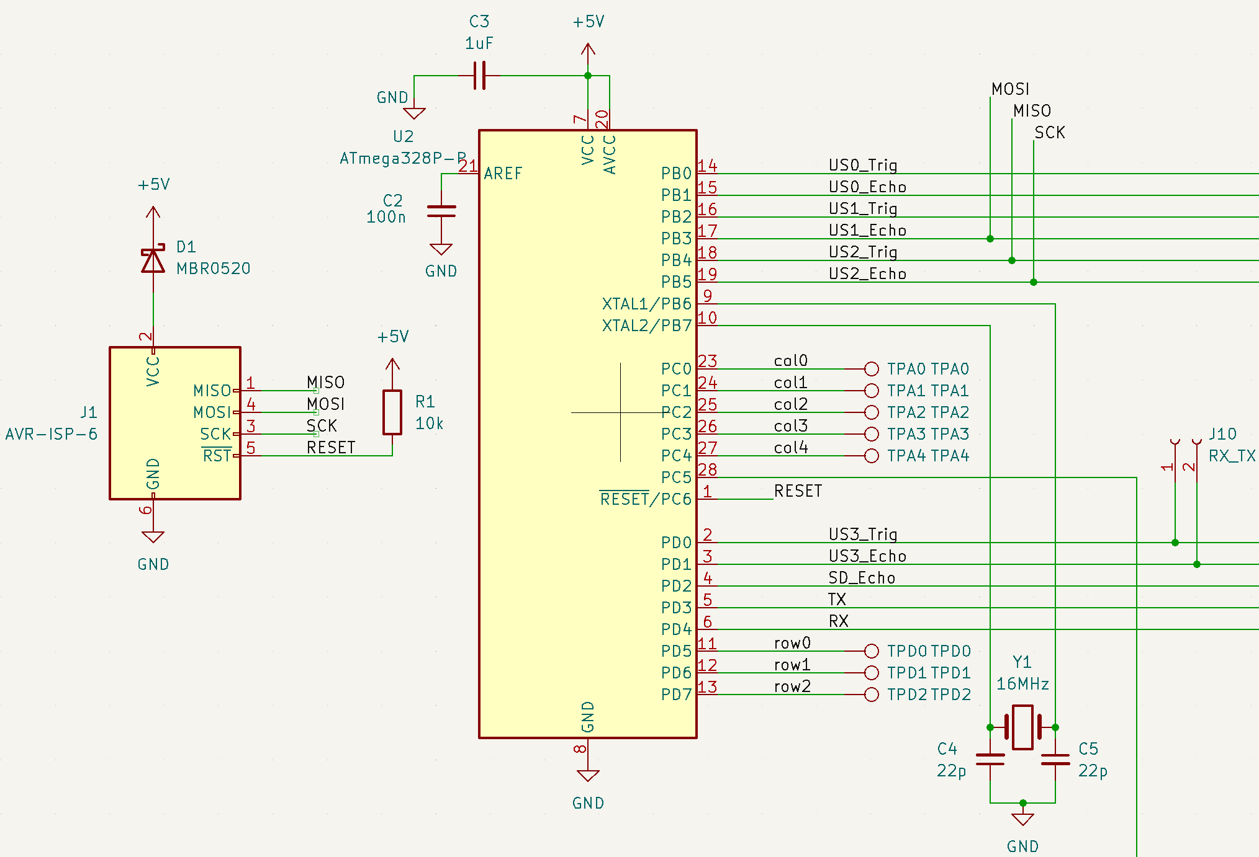

Figure 2.3: Crib Control Subsystem Schematic

### 2.2.3 Crib Power Subsystem

The crib power subsystem is responsible for providing the battery to the corresponding subsystems on the crib PCB board. As shown in Figure 2.4, the power source is a 9 V and 1300 mAh rechargeable battery connected to a linear voltage regulator. The regulator converts the input to output voltage based on the equation (2.2) [6]:

$V_{OUT}=1.25 V×(1+\frac{R_{2}}{R_{1}})$ (2.2)

Therefore, to derive a 5 V output, we choose R1 and R2 based on a proportion of 3. For example, choosing R1 and R2 to be 330 Ω and 110 Ω, respectively, allows us to obtain an output voltage of 5 V. Besides, the output current is supposed to be less than 100 mA. Since the power source is 1300 mAh, the power source can maintain operation for more than 10 hours. A switch is placed between the battery and the regulator to control the on/off state of the entire crib system.

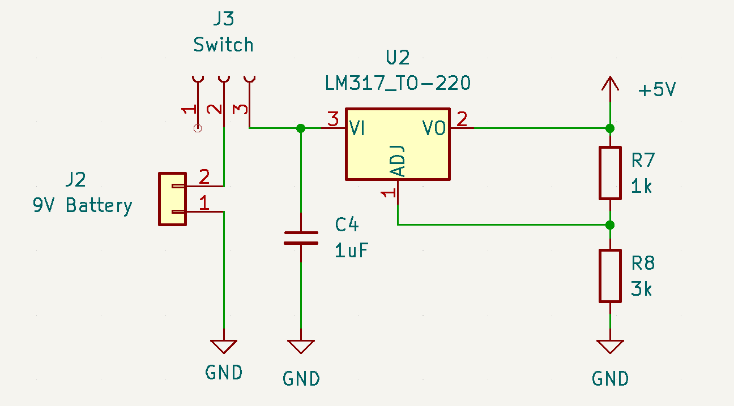

Figure 2.4: Crib Power Subsystem Schematic

## 2.3 Monitor System

### 2.3.1 UI Subsystem

The UI subsystem is responsible for notifying parents about the crib's event generation. We used an LCD screen to display a striking visual prompt to parents. Besides, we assigned different background colors and texts when related events happened to differentiate the emergency level. For instance, the screen displays white text with a red background color while the baby is trying to climb over the crib, and the screen displays white text and a green background if the baby is asleep and quiet.

In addition, we placed a buzzer along with the screen for auditory stimuli. We set the buzzer to turn on only if the screen turned red, indicating the highest emergency events, such as climbing over the crib or crying. Table 2.2 describes how the screen and buzzer work under different signals.

|  |  |  |  |
| --- | --- | --- | --- |
| Event | Text color | Screen background color | Buzzer State (On/Off) |
| Climbing over the crib | White | Red | On |
| Crying | White | Red | On |
| Crawling | Black | yellow | On once |
| Staying quiet or asleep | White | Green | Off |
| Unconnected with crib subsystem | White | Orange | On for every 3 seconds |

Table 2.2: Screen and Buzzer Reaction from Different Received Signals

### 2.3.2 Monitor Control Subsystem

The monitor control subsystem is designed for receiving messages from the crib subsystem via Bluetooth and assigning the corresponding instruction to the UI subsystem. The schematic looks similar to the crib control subsystem, as both are composed of a microcontroller, an in-circuit programmer, and a Bluetooth module. Since the more important part is on the software side, we designed a flowchart as in Figure 2.5 to demonstrate the logic of this subsystem.

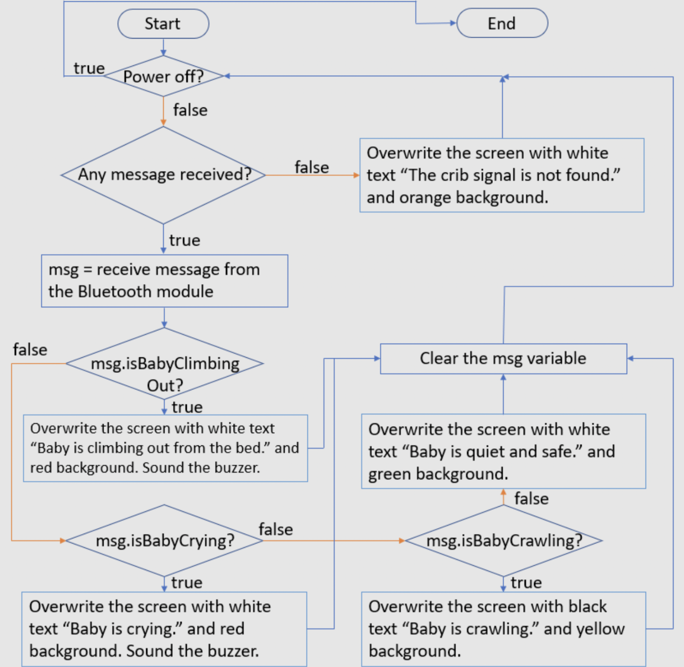

Figure 2.5 Monitor Control Subsystem Flow Chart

### 2.3.3 Monitor Power Subsystem

We design this subsystem to supply power to the entire monitor system. Like the crib power subsystem, we connect the 9 V battery to the linear voltage regulator with a few resistors and capacitors. Same to the crib power subsystem, the output current needs to be less than 100 mA to ensure the device has enough operation time.

# 3. Cost & Schedule

## 3.1 Cost

### 3.1.1 Labor

We assume the hourly salary is $ 35. And each of us contributes to the project for 12 hours every week. Since there are 15 weeks in a semester, then the labor cost for each member is:

$Labor Cost =35\frac{dollars}{hour}×2.5×12\frac{hours}{week}×15 weeks = \$ 15750$ (3.1)

The total labor cost for a group of three is also calculated:

$Total Labor Cost = 3×\$ 15750=\$ 47250$ (3.2)

### 3.1.1 Parts

Table 3.1 shows the information and the cost of each part used in our project.

|  |  |  |  |  |  |
| --- | --- | --- | --- | --- | --- |
| Description | Manufacturer | Part # | Quantity | Individual Cost ($) | Bulk Cost ($) |
| Ultrasonic Sensor | EPLZON | HC-SR04 | 4 | $ 2.60 | $ 10.40 |
| Pressure Sensor | DFRobot | SEN0294 | 15 | $ 5.00 | $ 75.00 |
| Sound Sensor | Sparkfun | SEN-14262 | 1 | $ 13.25 | $ 13.25 |
| Microcontroller | Microchip Technology | ATMega328p | 2 | $ 7.70 | $ 15.40 |
| Bluetooth Module | DEVMO | HC-05 | 2 | $ 11.33 | $ 22.66 |
| Buzzer | CUI Devices | CMI-1295IC-0585T | 1 | $ 1.18 | $ 1.18 |
| Screen | Adafruit | ST7789 | 1 | $ 17.50 | $ 17.50 |
| Battery | TQTHL | N/A | 2 | $ 5.22 | $ 10.44 |
| Voltage Regulator | Texas Instruments | LM317KCT | 1 | $ 0.69 | $ 0.69 |
| Switch | Adafruit | 805 | 2 | $ 0.95 | $ 1.90 |
| NMOS Transistor | ONSEMI | 2N7000 | 3 | $ 0.51 | $ 1.53 |
| Total |  |  |  |  | $ 169.95 |

Table 3.1: Parts Cost

### 3.1.3 Sum of Costs

$Sum of Costs =\$ 47250+\$ 169.95 =\$ 47419.95$ (3.3)

## 3.2 Schedule

|  |  |  |  |
| --- | --- | --- | --- |
|  | Yuhao | Xinlong | Feng |
| 2/5/2022-2/11/2022 | Research part number of the microcontroller & voltage regulator (Including writing the design document) | Research how the screen works. Draw the schematics of the UI system | Prepare all three types of sensors.  Research about the testing parameter of the sensor system |
| 2/12/2022-2/18/2022 | Design the Schematics of the Microcontroller & Power Subsystem (Including writing the design document) | Draw the schematics of the UI subsystem & PCB layout. Write design document | Design the connection to the Microcontroller & Power Subsystem and signal processing method |
| 2/19/2022-2/25/2022 | Draw the PCB Layout of the Microcontroller & Power subsystem.  Write the design document | Design PCB layout of the UI subsystem.  Write the design document | Design a supporting circuit to operate as a central terminal for all pressure sensors.  Write the team contract and the design document |
| 2/26/2022-3/4/2023 | Prepare for the design review. Design the prototype of the crib control subsystem | Prepare for the design review. Design the prototype of the monitor control subsystem | Prepare for the design review. Design the prototype of the crib sensor subsystem and adjust sensor parameters. |
| 3/5/2023-3/11/2023 | Adjust the prototype of the crib control and power subsystems | Adjust the prototype of the monitor control and power subsystems | Adjust the prototype of the crib sensor and power subsystems on breadboard |
| 3/12/2023-3/18/2023 | Spring Break | Spring Break | Spring Break |
| 3/19/2023-3/25/2023 | Fix the crib control and power subsystem PCB design if errors are identified in the prototype | Fix the monitor system PCB design if errors are identified in the prototype | Fix the sensor subsystem and PCB design if errors are identified in the prototype |

Table 3.2: Team Member Schedule

|  |  |  |  |
| --- | --- | --- | --- |
| 3/26/2023-4/1/2023 | Order a new PCB in the second round if needed. Write the individual progress report. Integrate parts into the crib system on PCB | Order a new PCB in the second round if needed. Write the individual progress report. Integrate parts into the monitor system on PCB | Order a new PCB in the second round if needed. Write the individual progress report. Integrate parts into the crib system on PCB |
| 4/2/2023-4/8/2023 | Integrate parts into the crib system PCB. Verify the hardware on the same system | Integrate parts into the monitor system PCB. Verify the hardware on the same system | Integrate parts into the crib system PCB. Verify the hardware on the same system |
| 4/9/2023-4/15/2023 | Finish hardware verification. Put subsystems together, and prepare for the mock demo. Build the physical crib model | Finish hardware verification. Put subsystems together, and prepare for the mock demo. Build the physical crib model | Finish hardware verification. Put subsystems together, and prepare for the mock demo. Build the physical crib model |
| 4/16/2023-4/22/2023 | Work on project revision based on the feedback from the mock demo | Work on project revision based on the feedback from the mock demo | Work on project revision based on the feedback from the mock demo |
| 4/23/2023-4/29/2023 | Prepare for the final demo and start the final report | Prepare for the final demo and start the final report | Prepare for the final demo and start the final report |
| 4/30/2023-5/3/2023 | Prepare for the final presentation and finish the final report | Prepare for the final presentation and finish the final report | Prepare for the final presentation and finish the final report |

Table 3.2 (continued): Team Member Schedule

# 4. Requirements & Verification

## 4.1 Crib System

### 4.1.1 Crib Sensor Subsystem

To ensure the sensor subsystem functions properly, we need to verify each category of sensors individually. Table 1 in Appendix A introduces some of the requirements we have for these three types of sensors.

The ultrasonic sensor must correctly inform the microcontroller if the baby is climbing, meaning that the baby rises to a height similar to the crib height. To verify this requirement, we mounted the ultrasonic sensors along the top of one side of the crib and uploaded a program to scan the ultrasonic sensor measurements. After turning on the device, we put an obstacle between the sensor and the guardrail. We checked if the horizontal distance between the ultrasonic sensor and the obstacle was smaller than 34 in. In this case, the distance measurements echoed back from the ultrasonic sensors were processed by the crib control subsystem and sent to the monitor, which displayed the information that the baby was climbing out of the crib.

To verify the sound sensor, we placed a speaker and a decibel meter together near the sound sensor. The speaker simulated the baby’s crying, and the meter measured the sound level. We measured the sound level four times and checked the screen display, concluding that the sound sensor performed correctly. Table 4.1 shows some examples of sound levels that are above or below the threshold for the “Crying” alert.

|  |  |
| --- | --- |
| Measured sound level (dB) | Screen display |
| 81.7 | Your baby is safe and quiet :) |
| 84.7 | Your baby is safe and quiet :) |
| 86.1 | Your baby is crying. |
| 87.6 | Your baby is crying. |

Table 4.1: Sound Intensity Measurement vs. Screen Display

The pressure sensor matrix is the last section of sensor subsystem components to be verified. We wrote and uploaded a program to scan the measurements from the pressure sensors and put an object of 5 N weight, such as a 500 ml bottle of water, on each pressure sensor. The pressure sensor detected a change in 5 N force since the screen displayed “Baby is moving on the crib,” which indicated that it recognized the change in baby’s position once it felt a 5 N force.

### 4.1.2 Crib Control Subsystem

For the crib control subsystem, we can refer to Table 2 in Appendix A to see more details on the specific requirements of this subsystem.

To test the crib control subsystem, we first verified whether the microcontroller could receive and analyze the sensor data by writing a program to convert sensor measurements into a three-bit bit code as described in Table 4.2, where each of the bits represented one state of the baby.

|  |  |  |
| --- | --- | --- |
| bit | Sensor | Baby’s state |
| least significant bit | Ultrasonic Sensor | Is climbing |
| middle bit | Sound Sensor | Is crying |
| most significant bit | Pressure Sensor | Is moving |

Table 4.2: Bit Assignment of Each Sensor with Baby’s Corresponding State

In this scenario, we uploaded a code into the microcontroller and used serial monitor display to check if the data processing is successful. As Table 4.3 demonstrates, we made each type of sensor respond to a state change of the baby individually and recorded the bit code displayed on the serial monitor.

|  |  |  |  |
| --- | --- | --- | --- |
| Sensor | Measurement change | Serial monitor display | Is bit mapping correct |
| Ultrasonic Sensor | Put obstacle between the sensor and the crib guardrail | 001 | Yes |
| Sound Sensor | Play a sound with pressure level above 86 dB near the sensor | 010 | Yes |
| Pressure Sensor | Put a 5 N object on the sensor | 100 | Yes |

Table 4.3: Baby’s State Change vs. Bit Code Displayed on the Serial Monitor

Based on the comparisons between the two tables, we concluded that the microcontroller could receive and analyze the data collected from the sensors.

The other requirement is to guarantee successful and fast data transmission from the crib to the monitor with a maximum delay of three seconds. We verified it based on the use of a timer to record the monitor reaction time. Once we changed the sensors' measurement, we started timing until the monitor changed the display from safe to climbing, crying, and moving. We performed 5 trials for each type of sensor and derived the following plot, which is Figure 4.1.

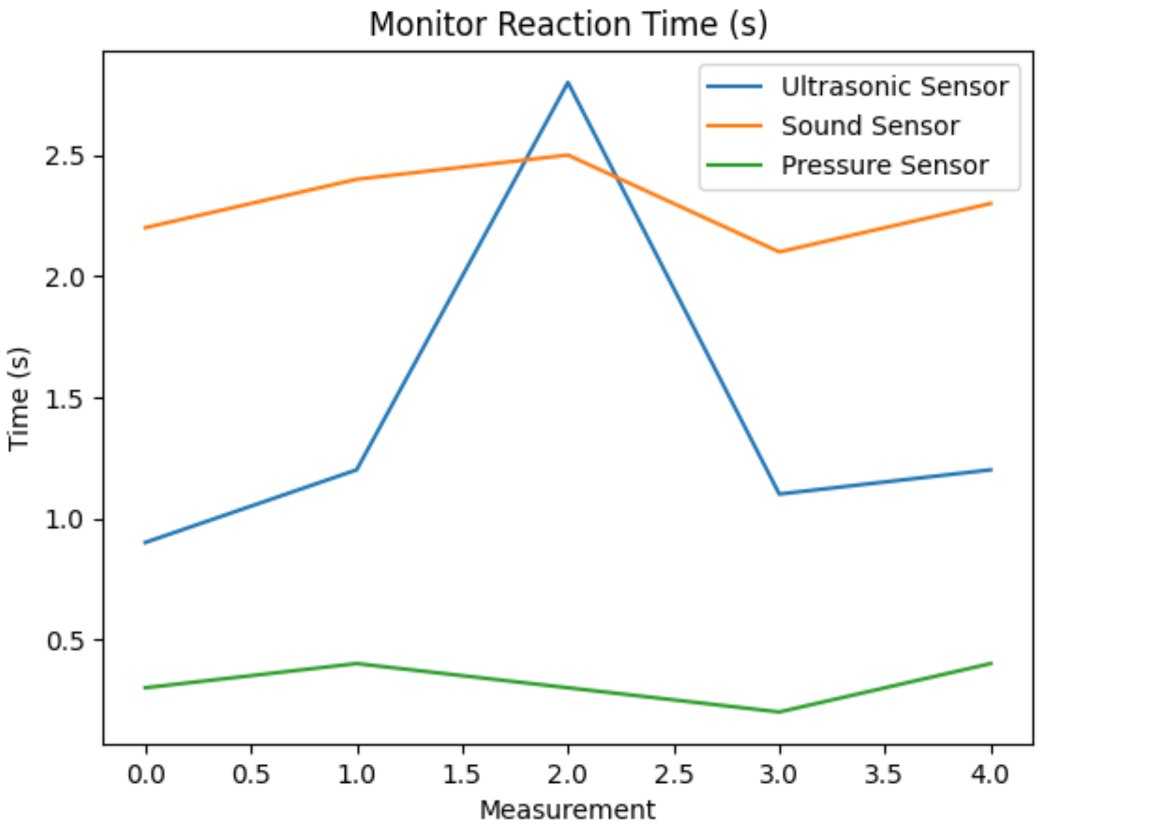

Figure 4.1 Monitor Reaction Time

From the plot, we observed that none of the monitor reaction time measurements exceeded three seconds, indicating the verification was successful.

### 4.1.3 Crib Power Subsystem

To make sure the Crib Power Subsystem works, we checked each part one by one. Referring to the detailed technical requirements in Table 3 in Appendix A, we can verify them to check the functionality of the subsystem. The power supply unit (PSU) needs to give a steady 5 V output voltage to the microcontroller and other parts. To check this, we hooked the PSU to a digital multimeter to see the output voltage. Next, we connected the PSU to the microcontroller and other parts to make sure they got a steady 5 V output.

There is also a voltage regulator connected to the power supply. First and foremost, the battery powering the entire system must provide a 9 V voltage, which means the input voltage for the connected voltage regulator is 9 V. To test this, we connected a multimeter to the input terminal (VI) of the regulator and ground the other end to measure the voltage difference, which should be within 9 V ± 0.5 V. Next, we moved the multimeter connections to the output terminal (VO) of the voltage regulator. We grounded the other end to check the voltage difference, ensuring that the input voltage to the PCB is within 5 V ± 0.3 V. Both values fall within the specified ranges, indicating the Crib Power Subsystem meets the requirements. The results showed that the battery voltage measured is 8.95 V, falling within the acceptable range. Simultaneously, the voltage difference between the output of the voltage regulator and the ground was 5.02 V as shown in Figure 4.2, which also lay within the tolerance. Based on these observations, we concluded that the Monitor Power Subsystem functions properly.

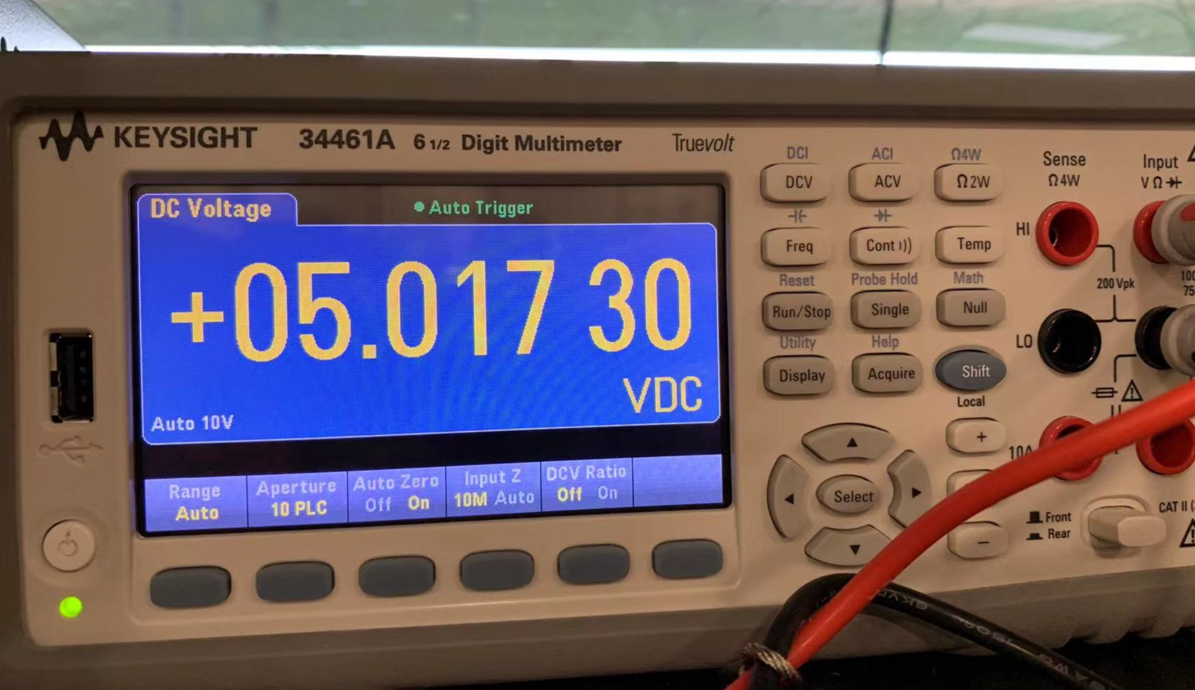

Figure 4.2 Voltage Measured from Crib Subsystem Voltage Regulator

## 4.2 Monitor System

### 4.2.1 UI Subsystem

To verify the functionality of this subsystem, we first tested whether the monitor and buzzer can perform the correct output corresponding to the input signal from the monitor PCB. Firstly, the monitor should be able to control the screen by displaying five different text content under certain conditions. To verify this, we sent five condition messages in sequence to the microcontroller: baby climbing, crying, moving, safe, and Bluetooth not connected. The monitor prints out the expected text with matched text and background color corresponding to each condition, illustrating successful verification of the first requirement. In Table 4 in Appendix A, the requirements for the monitor screen display and buzzer are shown in detail.

As Figure 4.3 shows, the corresponding text with color is: (a) “Your baby is climbing out of the crib.” (White text with a red background), (b) “Your baby is crying.” (White text with a red background), (c) “Your baby is moving on the crib.” (Black text with a yellow background), (d) “Your baby is safe and quiet. :)” (White text with a green background), (e) “The crib signal is not found.” (White text with orange background).

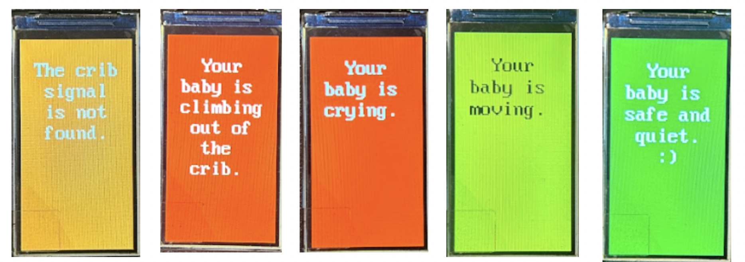

Figure 4.3 UI Subsystem Display

Next, the buzzer must produce a sound level of over 80 dB when connected in series with a 100 Ω ± 10 Ω resistor. To test this requirement, we connected the buzzer in series with a 100 Ω ± 10 Ω resistor and then used a decibel detection app on a smartphone to measure the sound level at a distance of 20 cm. The sound level exceeds 80 dB, indicating that the buzzer component functions properly. Therefore, the entire UI subsystem is working as expected.

The result of our test showed that all those texts matched correctly with each condition. Meanwhile, the buzzer emits an 84 dB beeping sound when tested 20 cm away from it. Therefore, we can confidently say that the UI subsystem is working as expected.

### 4.2.2 Monitor Control Subsystem

The monitor control subsystem is said to work if it displays the correct message on the screen and sounds the buzzer for the correct length in time given the safety status code. In Table 5 in Appendix A, we precisely introduced the requirements for this subsystem, and we are able to verify that the screen and the buzzer behave correctly for each of the message types. (a) When an ultrasonic sensor is blocked, the crib control subsystem sends a status code 001 to the monitor. The screen turns red and shows “Your baby is climbing out of the crib.” The buzzer sounds continuously for the duration of the safety event. (b) When the sound sensor detects a sound with an intensity greater than 86 dB for 2 s, the crib control subsystem sends a status code 010 to the monitor. The screen turns red and shows “Your baby is crying.” The buzzer sounds continuously for the duration of the safety event. (c) When any pressure sensor detects a change of force from below the 5 N threshold to above or the other way around, the crib control subsystem sends a status code 100 to the monitor. The screen turns yellow and shows “Your baby is moving.” The buzzer sounds upon the change in force and persists for 0.5 s. (d) When there is no safety event in concern, the crib control subsystem sends a status code 000 to the monitor. The screen turns green and shows “Your baby is safe and quiet. :)”. The buzzer does not sound. (e) When the crib system is shut down, or the monitor system is out of range of the Bluetooth of the crib system, the screen turns orange and shows “The crib signal is not found.” The buzzer beeps once for every 3 s.

The screen and buzzer can respond to the occurrence of any safety event within 3 s at all times. As we can observe from Figure 4.1, the screen can react within 3 s of any safety event. The buzzer works at the same time as the screen during the operation, so the alerts are produced within 3 s of a safety event.

### 4.2.3 Monitor Power Subsystem

Similar to the testing of the Crib Power Subsystem and in Table 6 in Appendix A, we employed the same verification method for evaluation. The results showed that the battery voltage measured 8.93 V, falling within the acceptable range. Simultaneously, the voltage difference between the output of the voltage regulator and the ground was measured as 5.08 V as shown in Figure 4.4, which also lay within the tolerance. Based on these findings, we conclude that the Monitor Power Subsystem is functioning properly.

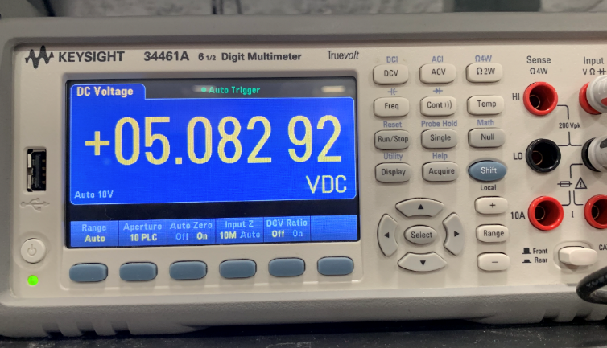

Figure 4.4 Voltage Measured from Monitor Subsystem Voltage Regulator

# 5. Conclusion

## 5.1 Accomplishments

Our safety crib makes accomplishments in detecting and reporting the baby’s safety situation to the parents. Once the baby is in a dangerous situation, the sensor subsystem can detect the data corresponding to his/her movement and cry. The control subsystem will process it to send the order to the monitor, and finally, the monitor will ask the UI subsystem to display the alert text message and sound. The system can cover most of the cases in real life, such as climbing out of the crib, crying, crawling, and turning on the bed. Therefore, we believe that this system can perform most of the tasks related to security warnings and monitoring the activity state of the baby.

## 5.2 Uncertainties

The detection and measurement of the ultrasonic sensors can sometimes be interfered with because of the physical guardrail in the crib, causing a false alarm. We did not expect that when we were doing the breadboard prototyping because, during our testing, the surrounding area was an open space without any obstructions within a radius beyond the test object.

## 5.3 Future Work / Alternatives

We plan to improve the packaging and PCB design of the project, especially in the crib system. It is more efficient and with less interference to settle the control part of three types of sensors on separate PCBs because it can weaken the impact of crosstalk. Meanwhile, the lower components-surface area ratio provides greater freedom of customization, such as increasing the pressure sensor array density and bringing measurement with higher precision. To put our product in industrial manufacturing, we can change the material of the crib from cardboard to pure wood and wrap the critical electrical components with electrical ducts. This ensures circuit stability while preventing the possibility of electric shock to the baby. At the same time, to reduce the false alarm rate of the ultrasonic sensor, we can also cover all four sides of the crib with sound-absorbing material to prevent interference between sound waves.

## 5.4 Ethical Considerations

In this section, we will comprehensively address any ethical concerns associated with this project. The IEEE Policies [7] acknowledge the potential impact of emerging technologies on the world and stress the importance of adhering to high standards in professional activities for IEEE members. Key principles relevant to our project encompass prioritizing public safety, health, and welfare, ensuring sustainability, and revealing any potential harm from our product's usage.

We will discuss potential ethical matters related to both the product itself and its development process, starting with those concerning the product. A primary consideration for users of our product is safety. Given the absence of research on ultrasound effects on post-natal infants, we can gain insights from the broader impact of ultrasound on humans. Our sensors will emit ultrasounds at a frequency of approximately 40 kHz. As per [8], there is no evidence to suggest that ultrasounds at 40 kHz and below 120 dB sound pressure level impact human hearing or cognitive functions [9]. Our ultrasonic sensor operates at 75 mW power, and assuming all power is converted to sound, the resulting sound pressure level is 108 dB, below the 120 dB threshold. Concerning biological tissue impact, diagnostic-level ultrasonic devices do not harm human tissue due to the negligible heat generated compared to physiological thermal temperature [10]. Our product controls ultrasound emission angles and patterns, ensuring that the infant will not be directly exposed to ultrasound unless they move beyond the crib's guardrail, which would trigger the guardian alarm. The ultrasound exposure duration will be less than five minutes daily, assuming the product is active for 24 hours. We will apply waterproof and insulating materials for circuit packaging to prevent fires resulting from short circuits in the pressure sensor lining. Besides the risk of fire hazard, our system is user-friendly regarding electrical safety, ensuring that even children will not experience electric shocks. This is because our power source is a 9 V battery, which does not cause an electric shock on human bodies.

Ethical concerns regarding the product development process are minimal. As indicated by [8-10], the ultrasonic transducer will not harm developers. Developers will not be directly exposed to the ultrasonic sensor 99% of the time. The project's power usage does not exceed 9 V, which is generally safe for developers. We will meticulously examine the connections between elements to prevent short circuits during assembly and testing. The development process will be guided by the principles of sustainable development, with careful planning of material requirements and waste reduction efforts. Based on these considerations, no individual will be harmed by the product during testing or operation.

There is no established safety and regulatory standard for frequency and acoustic intensity limits of ultrasound in non-clinical and consumer products. Comparing our product to the limits specified in part 2 of IEC 60601 for clinical-use products [11], our estimated ultrasound intensity of 0.0133 W/cm2 is significantly lower than the 3 W/cm2 limit, and the frequency is well above the human audible range while still within the safe low-frequency ultrasound range for humans.

# References

|  |  |
| --- | --- |
| [1] | Parenting Desk, "Is your toddler climbing out of the crib? Here is what you can do to prevent them," 1 May 2023. [Online]. Available: The Indian Express. |
| [2] | "Decoding your baby's cry," baby gooroo, 28 December 2021. [Online]. Available: https://babygooroo.com/articles/decoding-your-babys-cry. |
| [3] | Dejan, "Ultrasonic Sensor HC-SR04 and Arduino – Complete Guide," How to Mechatronics, [Online]. Available: https://howtomechatronics.com/tutorials/arduino/ultrasonic-sensor-hc-sr04/. |
| [4] | L. E. Calderon, L. D. Carney and K. T. Kavanagh, "The Cry of the Child and its Relationship to Hearing Loss in Parental Guardians and Health Care Providers," *National Library of Medicine,* 2015. |
| [5] | "ECE Illinois," [Online]. Available: https://courses.engr.illinois.edu/ece445/wiki/#/microcontrollers/avr. |
| [6] | "LM317 3-Terminal Adjustable Regulator," Texas Instrument, 2020. |
| [7] | "IEEE POLICIES," 2023. |
| [8] | A. D. Battista, "The effect of 40 kHz ultrasonic noise exposure on human hearing," *the 23rd International Congress on Acoustics,* vol. 200, September 2019. |
| [9] | A. D. Battista, A. Price, R. Malkin, B. W. Drinkwater, P. Kuberka and C. Jarrold, "The effects of high-intensity 40 kHz ultrasound on cognitive function," *Applied Acoustics,* vol. 200, 2022. |
| [10] | D. B. Moyano, D. A. Paraiso and R. A. González-Lezcano, "Possible Effects on Health of Ultrasound Exposure, Risk Factors in the Work Environment and Occupational Safety Review," *Healthcare,* 2022. |
| [11] | F. A. Duck, "Medical and non-medical protection standards for ultrasound and infrasound," *Progress in Biophysics and Molecular Biology,* vol. 93, no. 1-3, pp. 176-191, 2007. |

# Appendix A Requirement and Verification Table

|  |  |  |
| --- | --- | --- |
| Requirement | Verification | Verification Status  (Y or N) |
| 1. The ultrasonic sensor should inform the MCU if the baby reaches a height of 20 in ± 0.5 in from the bottom of the crib. | 1. Mount the ultrasonic sensors along the short side of the crib at a height of 20 in ± 0.5 in from the bottom of the crib. Write and upload a program that controls the ultrasonic sensors to measure the distance from one short side of the crib to another and programmatically check whether the distance measured is equivalent to 34 in ± 1 in. Verify that the LCD screen shows the “Baby is climbing out of the crib” alert when the distance measured is out of the range of 34 in ± 1 in. | Y |
| 2. The sound sensor should correctly report to the MCU when there is a sound above 86 dB measured at 34 in ± 1 in from the sensor. | 2. Place a consistent sound source at 34 in ± 1 in from the sound sensor, place a decibel meter within 1 in from the sound sensor, and adjust the volume of the sound source such that the readings from the decibel meter are above 86 dB. Verify that the LCD screen shows the “Baby is crying” alert. | Y |
| 3. The pressure sensor array should correctly detect the change in the number and positions of the 15 pressure sensors that feel a perpendicular force greater than 5 N. | 3. Run a program that scans the readings of pressure sensors. Verify that the LCD screen displays the “Baby is moving on the crib” notification on the screen if the pressure sensor matrix detects a change in the number or position of pressure sensors that detect a force above 5 N. | Y |

Table 1: Crib Sensor Subsystem R/V

|  |  |  |
| --- | --- | --- |
| Requirement | Verification | Verification Status  (Y or N) |
| 1. The microcontroller can process data from all sensors and generate informational data about the safety status in the crib at all times.   1. The alert data for “Climbing” is generated if the reading of any of the ultrasonic sensors is less than 32 in or greater than 34 in; 2. that for “Crying” is generated if the GATE signal from the sound detector is high for at least 2 s; 3. that for “Moving” is generated if the number or positions of readings above 5 N changed when compared to the readings stored at most 2 s ago. | 1. Write a program that converts sensor readings into a three-bit bit code, where each bit represents the occurrence of one safety event.   1. Generate the alert for “Climbing” if the reading of any of the ultrasonic sensors is less than 32 in or greater than 34 in; 2. Generate the alert for “Crying” if the GATE signal from the sound detector is high for at least 2 s; 3. Generate the notification for “Moving” if the number or positions of pressure sensors that feel a force greater than 5 N changed when compared to readings stored at most 2 s ago. Verify that the correct alert or notification is made on the LCD screen every time an event is identified. | Y |
| 2. The microcontroller can deliver informational data to another device with its Bluetooth within 10 m and with at most three 11.4 cm or thicker walls in between. The time it takes to send the data should be within 3 s. | 2. Send the bit-code representing the data through Bluetooth to another Bluetooth device 10 m away and with at most three 11.4 cm or thicker walls in between to show that the notification made is correct on the LCD screen. Time the process starting from the occurrence of the event to the display of the message and verify that it is within 3 s. | Y |

Table 2: Crib Control Subsystem R/V

|  |  |  |
| --- | --- | --- |
| Requirement | Verification | Verification Status  (Y or N) |
| 1. The input to the VI pin of the voltage regulator is 9 V ± 0.5 V. | 1. Connect the anode of the battery to the VI and the cathode to the ground. Close the switch. Use a multimeter, place one probe at VI and another at the GND, and verify that the voltage difference is 9 V ± 0.5 V. | Y |
| 2. The output of the VO pin of the voltage regulator, the input to the crib sensor subsystem, and the input to the crib control subsystem is 5 V ± 0.3 V. | 2. Connect the anode of the battery to VI and the cathode to the ground. Close the switch. Use a multimeter, place one probe at VO and another at the GND, and verify that the voltage difference is 5 V ± 0.3 V. Repeat the measurement for the power input to the chips, Bluetooth module, and sensors. | Y |

Table 3: Crib Power Subsystem R/V

|  |  |  |
| --- | --- | --- |
| Requirement | Verification | Verification Status  (Y or N) |
| 1. The microcontroller can control the screen to display five different contents under the five corresponding situations: climbing, crying, moving, safe, and not-connected. | 1. Send different possible safety status messages to the microcontroller such that each of the five different contents can show up once. Verify that the five different contents are as follows:   1. “Your baby is climbing out of the crib.” (White text with a red background); 2. “Your baby is crying.” (White text with a red background); 3. “Your baby is moving on the crib.” (Black text with a yellow background); 4. “Your baby is safe and quiet. :)” (White text with a green background); 5. “The crib signal is not found.” (White text with orange background). | Y |
| 2. The buzzer can emit a sound greater than 80 dB when connected in series with a 100 Ω ± 10 Ω. | 2. Connect one end of the buzzer in series with a 100 Ω ± 10 Ω resistor and another end to GND, use a sound pressure level detector on a phone, and place the microphone of the phone within 20 cm of the buzzer to verify that the emitted sound is above 80 dB. | Y |

Table 4: Monitor UI Subsystem R/V

|  |  |  |
| --- | --- | --- |
| Requirement | Verification | Verification Status  (Y or N) |
| 1. The Bluetooth module can receive messages from another Bluetooth device and deliver them correctly to the microcontroller. The microcontroller can use the messages to control the peripherals at all times. | 1. Send a bit code representing the safety status to the Bluetooth module at the monitor system. Control the display to show the user message corresponding to the bit code on the screen. Verify that the screen displays the correct message. Check whether the buzzer sounds when the bit code indicates code-red events (either the bit for “climbing” or “crying” is set). | Y |
| 2. The time elapsed from a safety event starts to the generated alert should be within 3 s. | 2. Time the process with a stopwatch from the event start to the occurrence of the alert and check whether it takes smaller than 3 s. | Y |

Table 5: Monitor Control Subsystem R/V

|  |  |  |
| --- | --- | --- |
| Requirement | Verification | Verification Status  (Y or N) |
| 1. The input to the VI pin of the voltage regulator is 9 V ± 0.5 V. | 1. Connect the anode of the battery to the VI and the cathode to the ground. Close the switch. Use a multimeter, place one probe at VI and another at the GND, and verify that the voltage difference is 9 V ± 0.5 V. | Y |
| 2. The output of the VO pin of the voltage regulator, the input to the UI subsystem, and the input to the monitor control subsystem is 5 V ± 0.3 V. | 2. Connect the anode of the battery to VI and the cathode to the ground. Close the switch. Use a multimeter, place one probe at VO and another at the GND, and verify that the voltage difference is 5 V ± 0.3 V. Repeat the measurement and verify the readings for the power input to the microcontroller, screen, and buzzer. | Y |

Table 6: Monitor Power Subsystem R/V

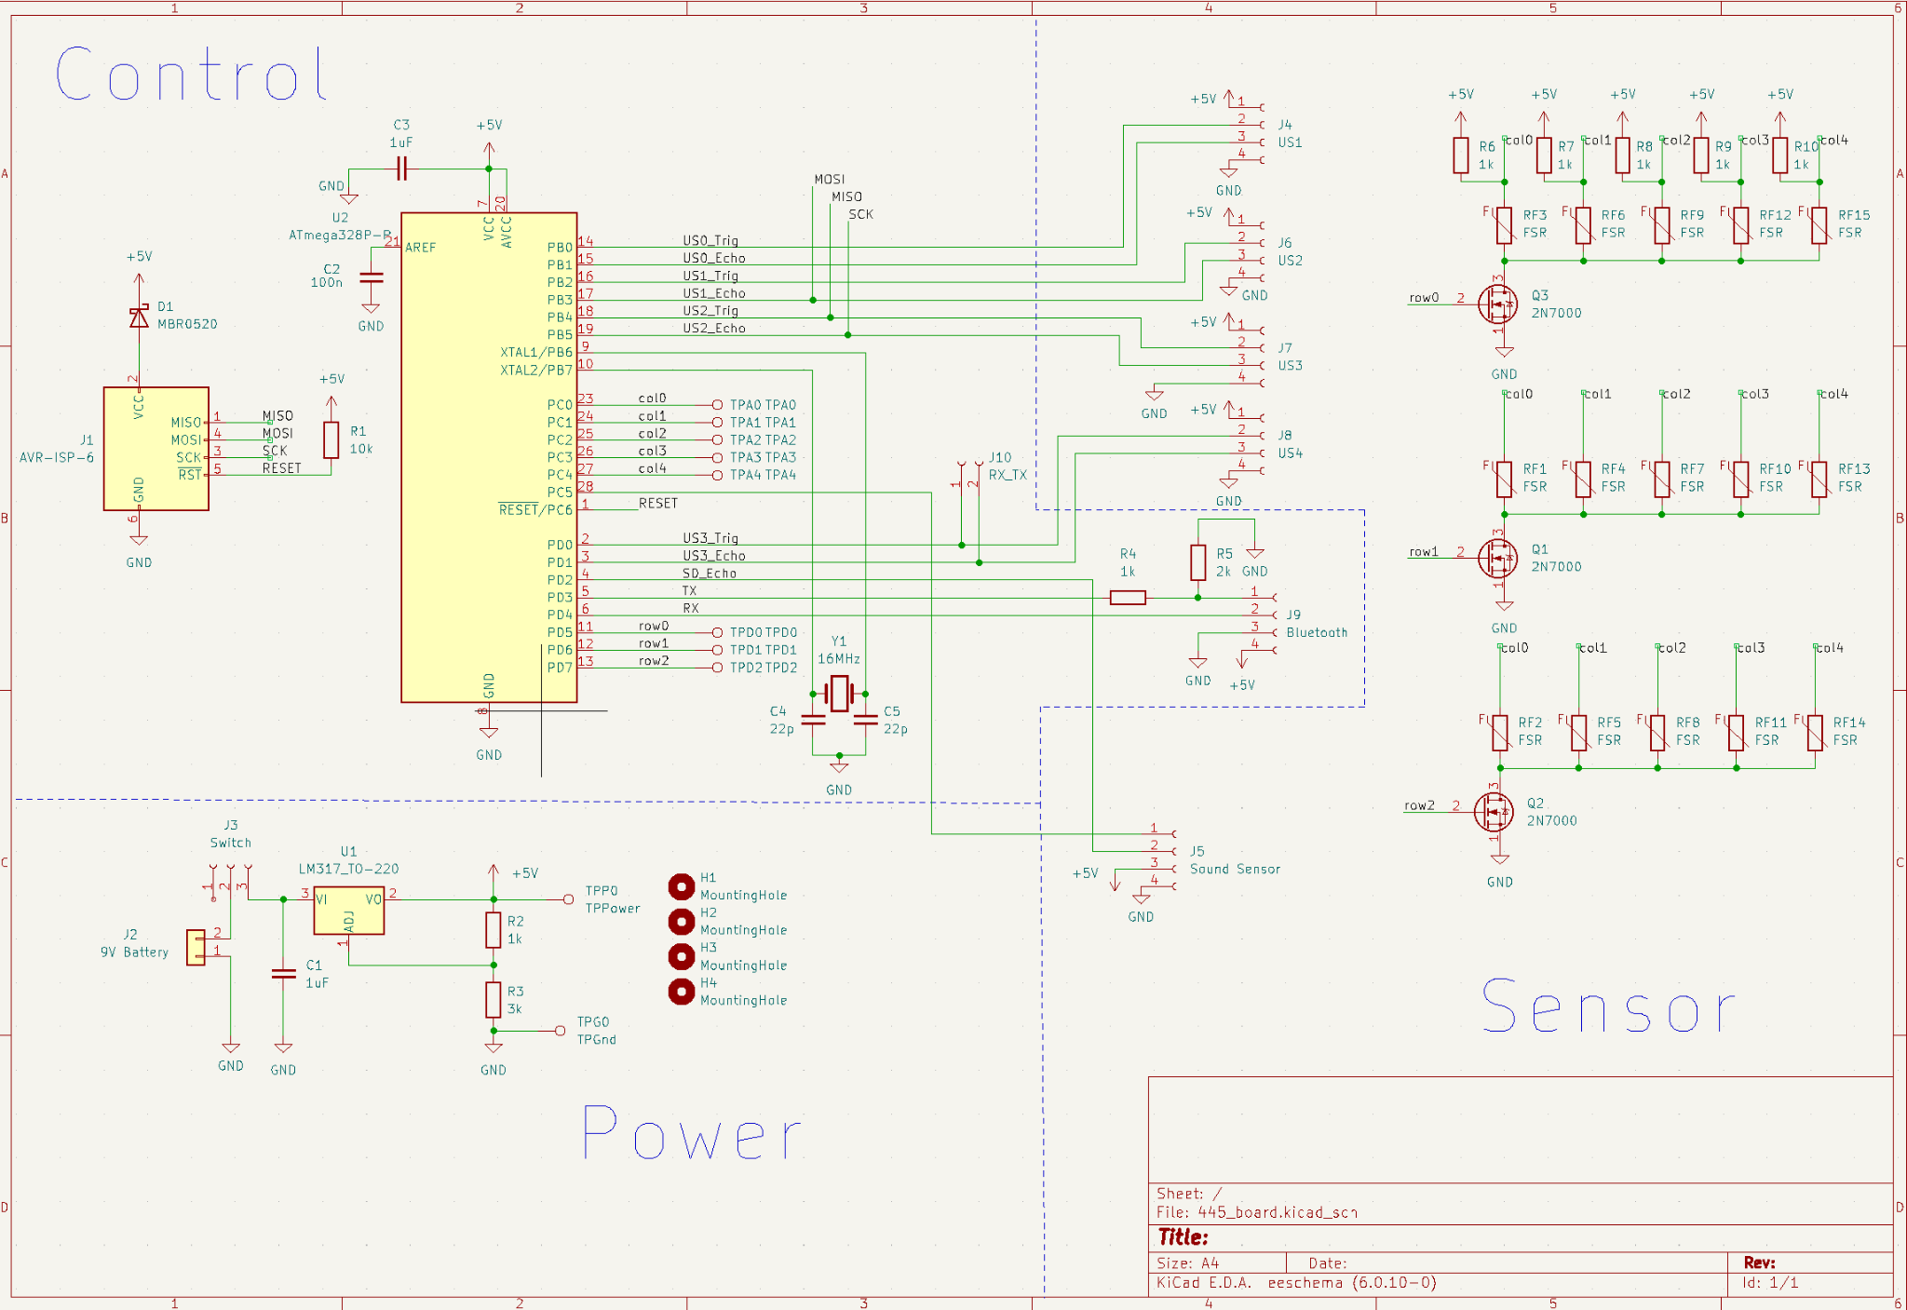

Figure 1: Crib System Schematic

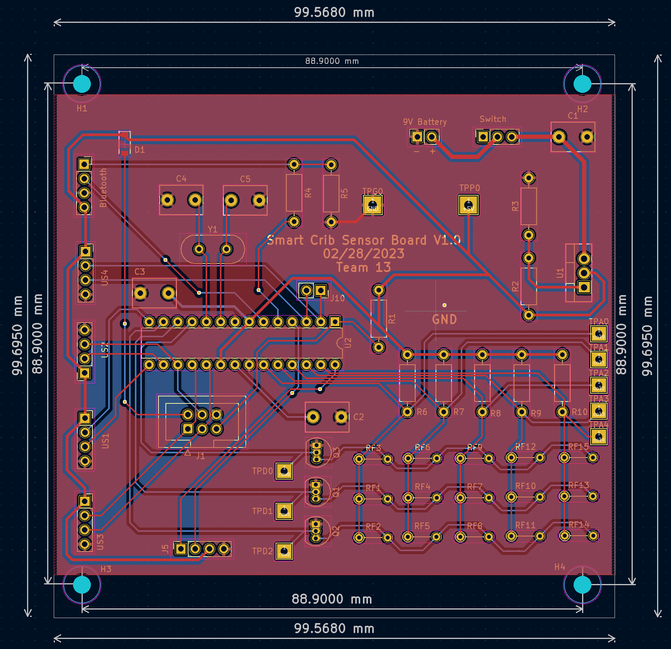

Figure 2: Crib System PCB Layout

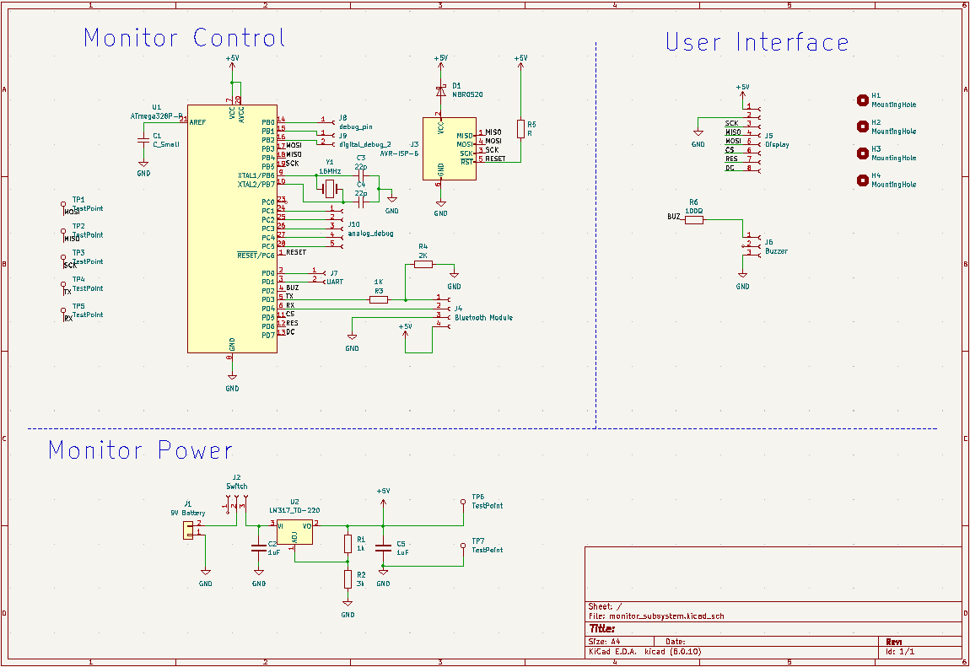

Figure 3: Monitor System Schematic

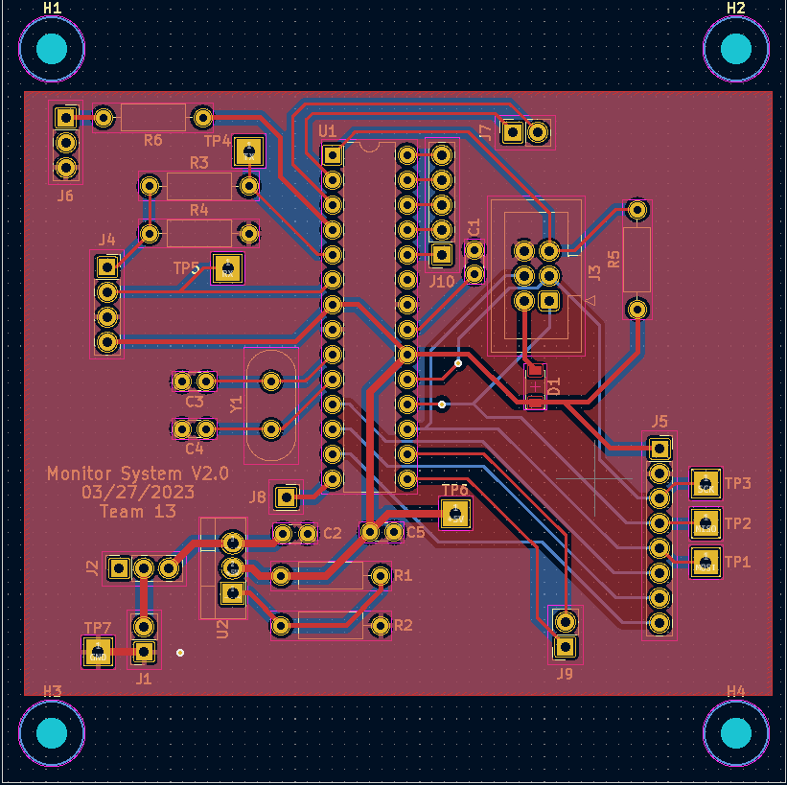

Figure 4: Monitor System PCB Layout